**B. V. V. Sangha’s**

**BASAVESHWAR ENGINEERING COLLEGE (Autonomous)**

**BAGALKOT**



**2017-2018**

**DEPARTMENT OF ELECTRONICS AND COMMUNICATION ENGINEERING**

**MINI PROJECT SYNOPSIS ON**

**KRISHI MITRA (FARMingBOT)**

**TEAM MEMBERS NAME: USN: ROLL NO**:

SURESH 2BA15EC045 1

SAGAR PAWAR 2BA15EC068  27

RUTWIK PATIL 2BA15EC065  24

SAGAR B LINGNUR 2BA15EC067 26

**GUIDE NAME:** Dr. B.G. SHIPPERMATTI **GUIDE SIGN:**

**H. O. D NAME:** Dr. P.N. KULKARNI **H.O.D SIGN:**

**DATE:** 17/1/18

**INDEX**

|  |  |  |
| --- | --- | --- |
| **Sl No.** | **CONTENTS** | **Pg. No.** |
| 1. | Introduction | 3 |
| 2. | Model Diagram | 3 |
| 3. | Description | 4 |
| 4. | Components Required | 4 |
| 5. | Hardware Control Flow | 5 |
| 6. | Software Control Flow | 5 |
| 7. | Applications | 6 |
| 8. | Disadvantages | 6 |

**INTRODUCTION:**

**Agricultural robots** are a robot deployed for agricultural purposes. Emerging applications of robots or drones in agriculture include weed control, cloud seeding,planting seeds, harvesting, environmental monitoring and soil analysis.

Agriculture has always been the backbone of India for a long time. The project we put forth has been designed to automate the work of a farmer so that he can tirelessly perform his farming tasks. We intend to automate the most common and frequent tasks of the farmer.

Our team aims at building a robot that can perform almost all processes prior to harvesting including sowing, weed control and watering.

This is achieved by an electro-mechanical system that can be programmed to do the tasks.

**MODEL DIAGRAM:**

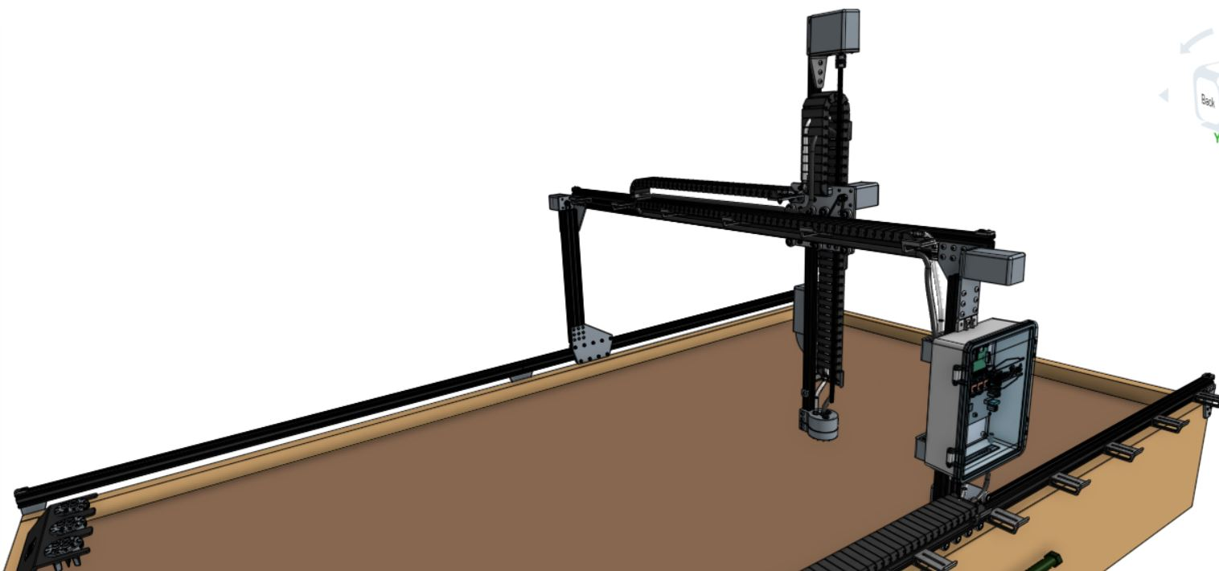

Fig: CAD model of a fully Automated FARMingBOT

The above is CAD model of the Robot as visualized on how a fully completely fabricated robot will look like by us.

We intend to build a robot that is simple and almost fully automated that can take on most time consuming and labor-intensive tasks for the farmer.

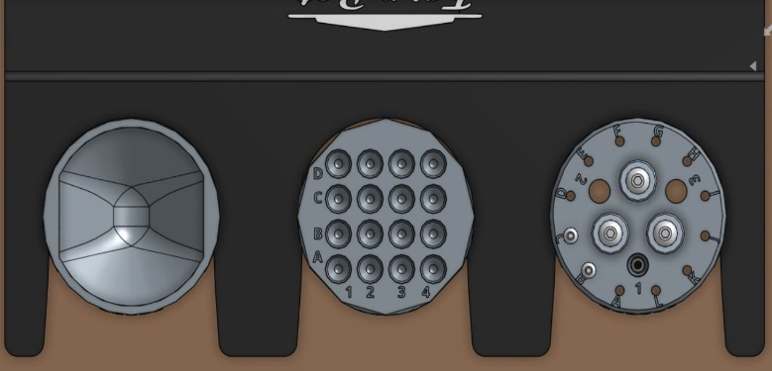

Fig: CAD model of various Tools

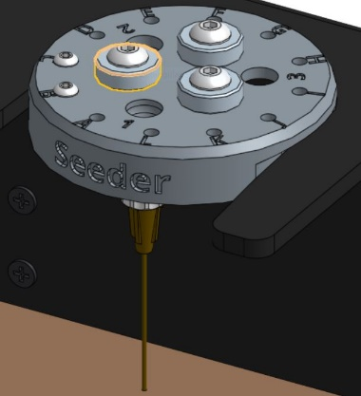

Fig: CAD model of Seeding Tools

**DESCRIPTION:**

The robot performs different tasks through automatically attaching different tools to a universal tool mount, including a seed injector, a watering nozzle and a tool to bury weeds. The machine is able to spray weedicides and pesticides the planted area using the water sprayer tool and also using a camera that is used to live stream the entire robot working along with all plants in the area to the locations of the planted seedsto the farmer to his/her mobile phone.

The machine uses linear guides in the X, Y, and Z axis with the tools.

electronics stack consists of a Raspberry Pi 3 and /or Arduino UNO with relay circuit and a camera to live stream data.

**COMPONENTS REQUIRED:**

* 4 DC Motors, Wires
* Supply 12V DC
* Seeding, Watering tools
* Motor Driver Circuit
* Raspberry Pi 3 Model B + Pi Cam (Arduino UNO)
* Router Connection
* Equivavelent materials for fabrication

**HARDAWRE CONTROL FLOW:**

The above table shows the different characters that can be displayed on LCD along with their ASCII code

**SOFTWARE CONTROL FLOW:**

**APPLICATIONS:**

* Sowing, watering and pesticide/weedicide application process is automated.
* Crop growing process is made efficient for large fields.
* It is useful at time of low availability of labor.
* Possibility to improve the machine without significant design changes.
* It reduces the time of farmer so he can do other tasks at hand.
* Live stream video of machine working and status is obtained.

**DISADVANTAGES:**

* Initial investment is high.
* Not entirely farmer independent.
* Requires a basic educated farmer to operate.